w



CLOUD COMPUTING LAB
BSE ( V-B )

Submitted By:
Musfira Farooq
Roll No:
2023-BSE-045
Submitted To:
Sir Muhammad Shoaib

LAB 03

Working with Git History, Stashing, and Reverting Commits

Task 1

Handling Local and Remote Commit Conflicts (Pull vs Pull --rebase)
- Remote change committed on GitHub
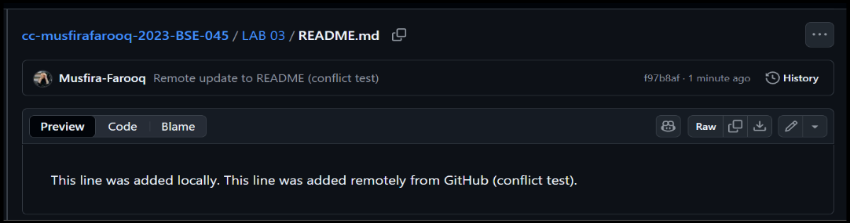
- Local change committed on your machine
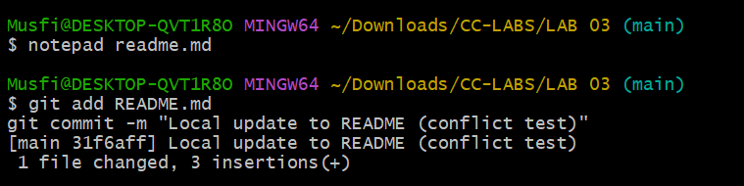
- Push rejected due to remote changes
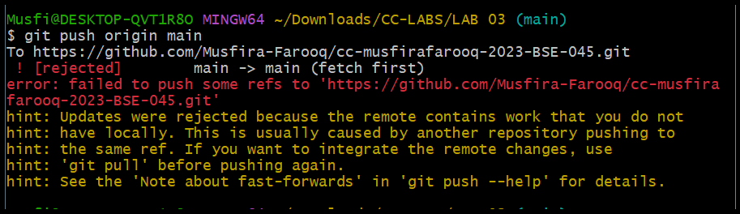
- Merge commit after git pull --no-rebase
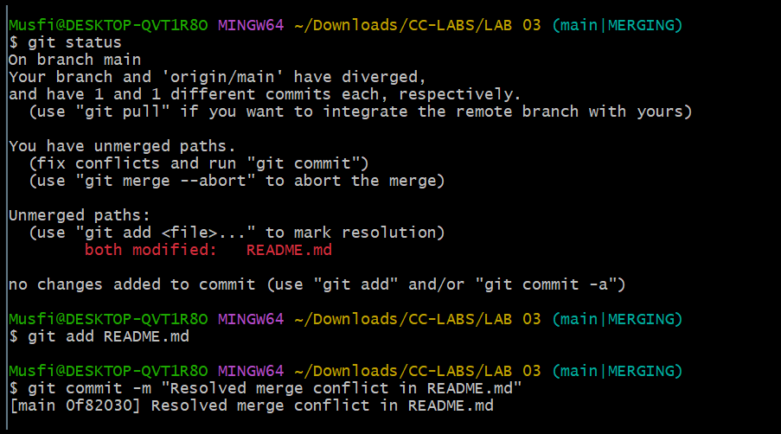
- Push successful after merge
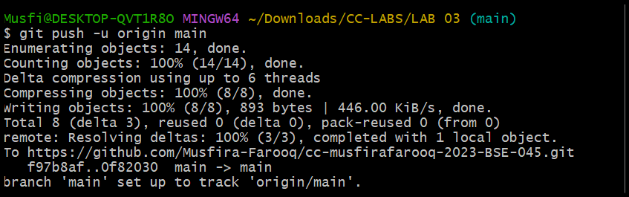
- Local commits rebased on top of remote changes (git pull --rebase)
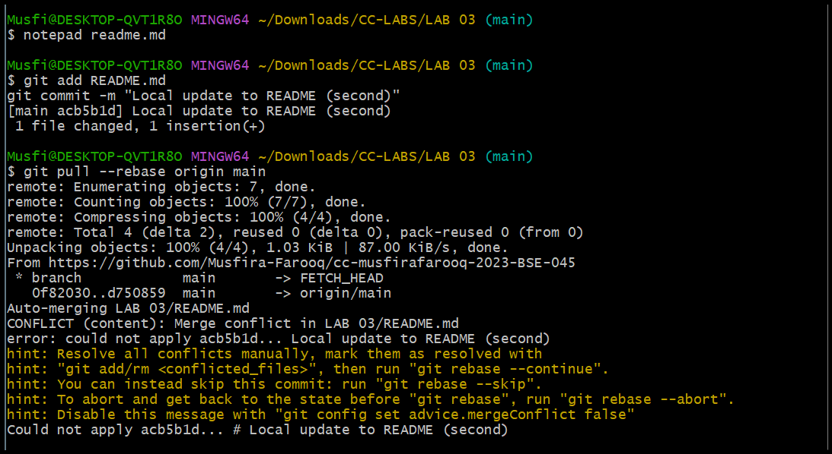
- Push successful after rebase
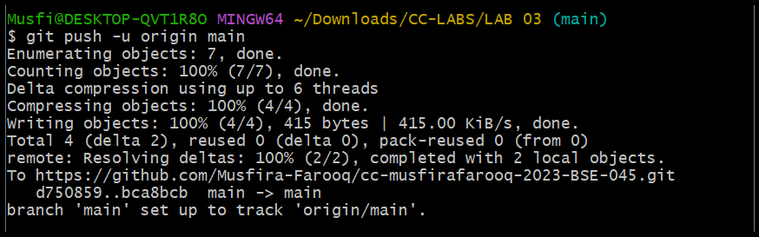

Task 2

Creating and Resolving Merge Conflicts Manually
- Remote conflicting change committed on GitHub
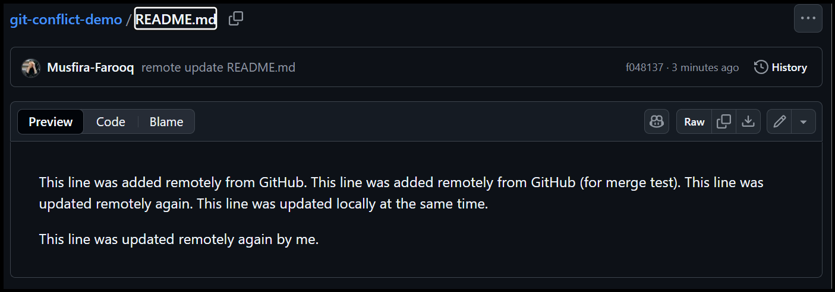
- Local conflicting change edited in VS Code
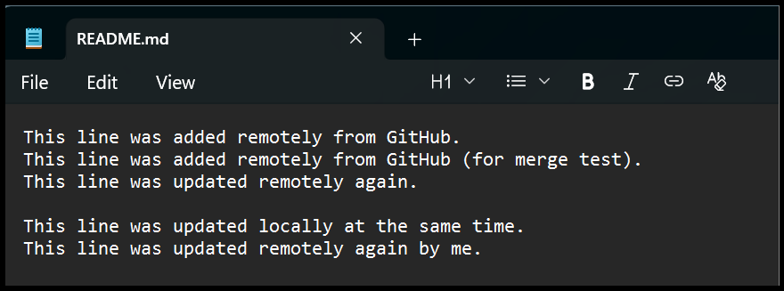
- Local conflicting change committed
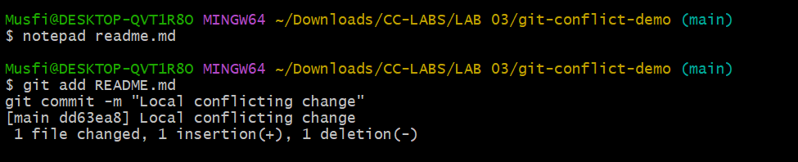
- Push rejected due to conflict
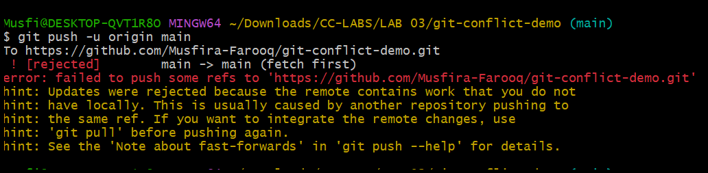
- Conflict message shown during rebase
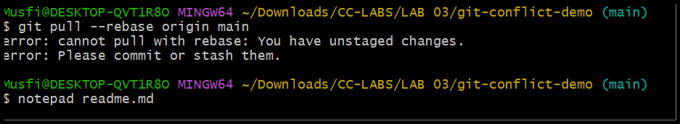
- File after manual conflict resolution
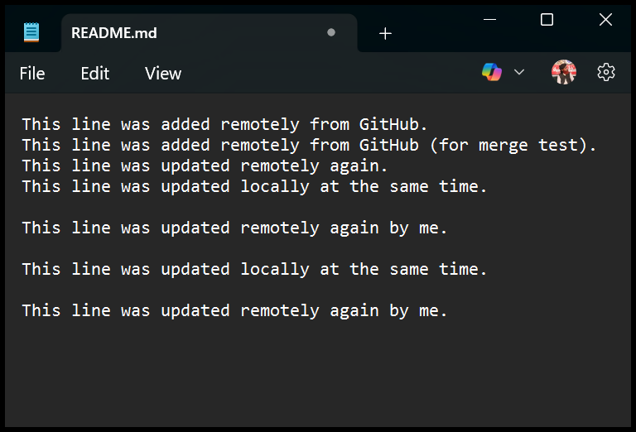
- Rebase continued after resolving conflict
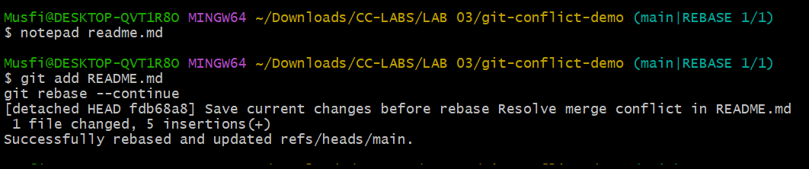
- Push successful after resolving conflict
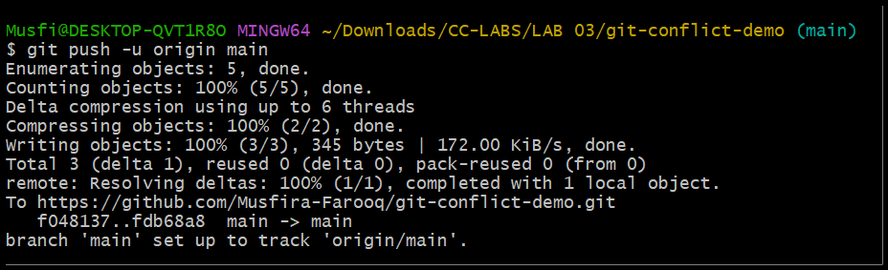

Task 3

Managing Ignored Files with .gitignore and Removing Tracked Files
- Textfiles directory added and pushed to GitHub
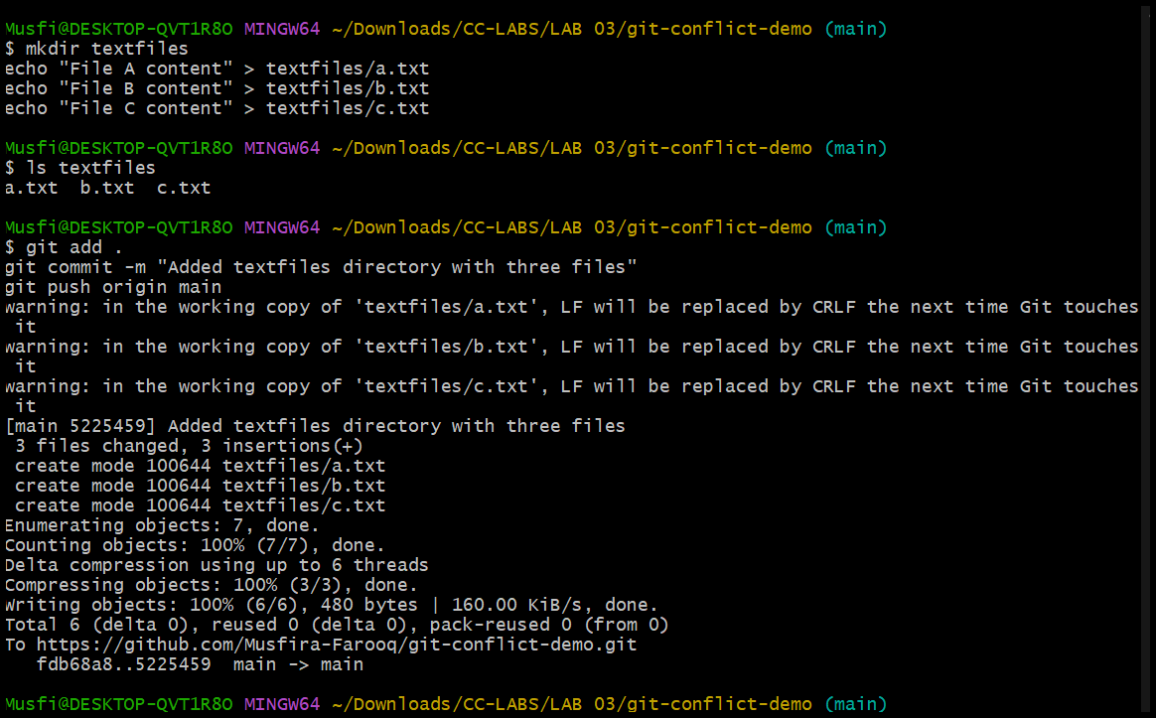
- .gitignore added and pushed to ignore textfiles
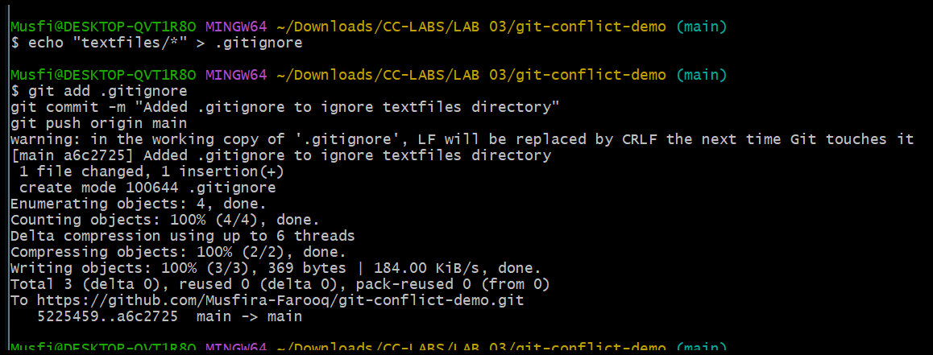
- Textfiles still visible on GitHub after adding .gitignore
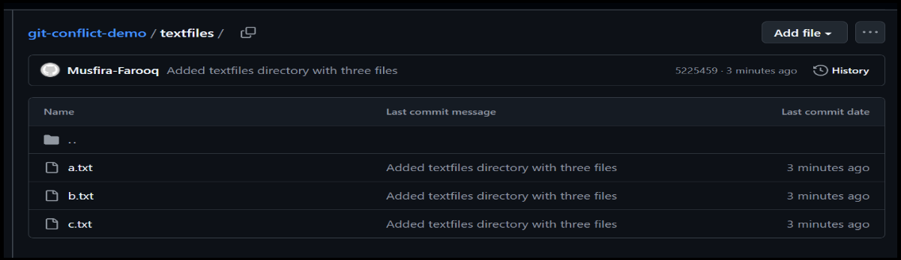
- Tracked textfiles removed from Git cache and pushed
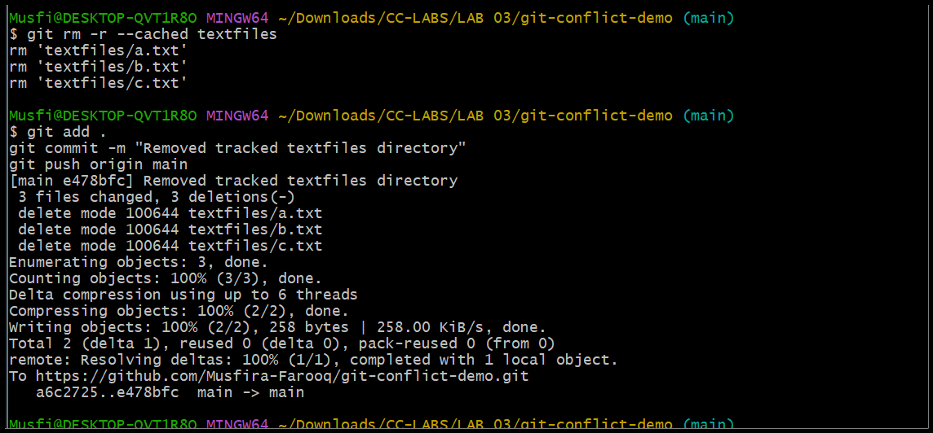
- Textfiles folder removed from GitHub remotely
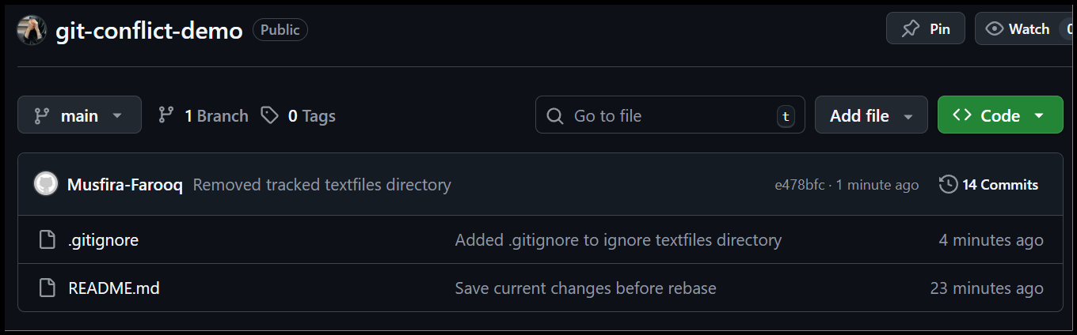
Task 4
Create Temporary Changes and Use git stash
- Changes made and committed on feature branch
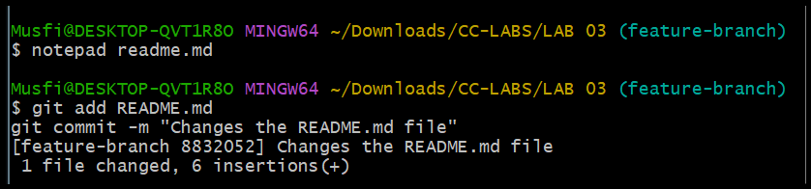
- Error shown when trying to switch branch with uncommitted changes
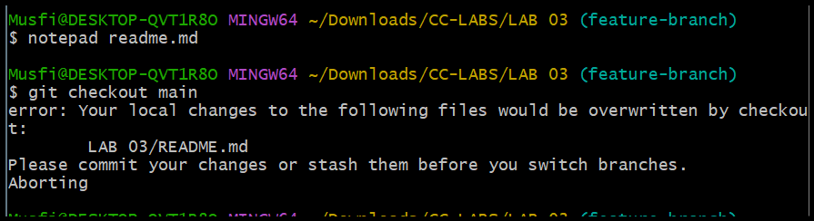
- Changes stashed using git stash
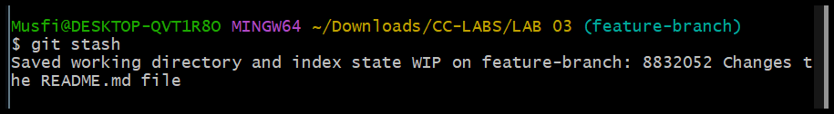
- Branch switch successful after stashing
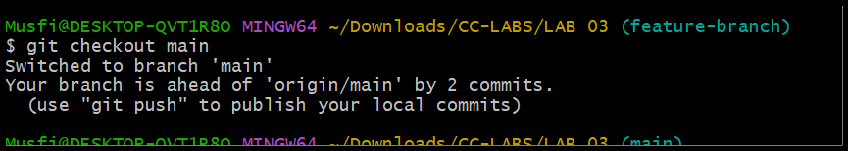
- Returned to feature branch
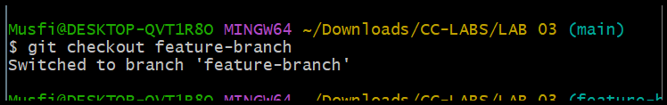
- Working directory clean after switching back
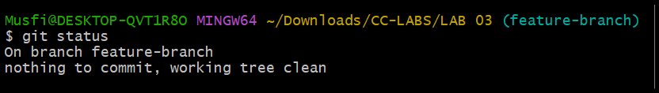
- Stashed changes restored with git stash pop
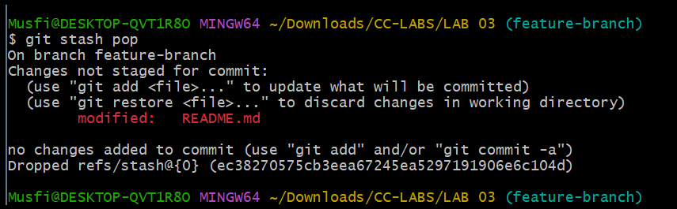
Task 5
Checkout a Specific Commit Using git log
- Commit history viewed with git log –oneline
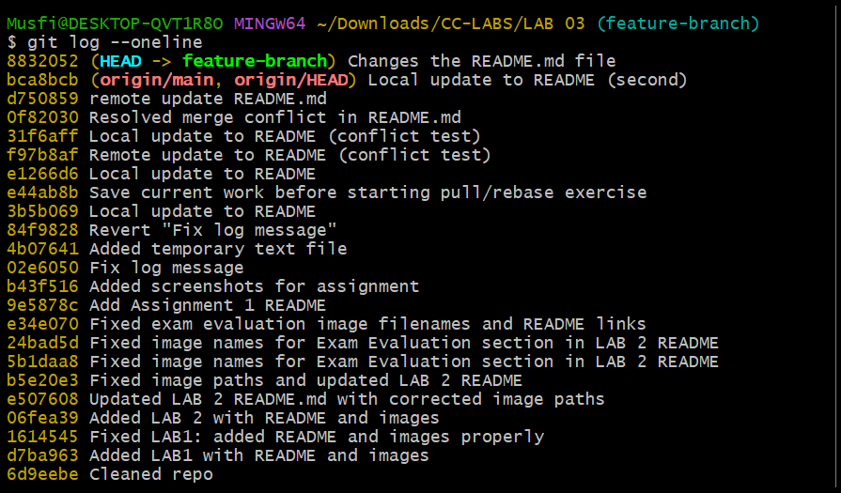
- Checked out a specific commit (detached HEAD)
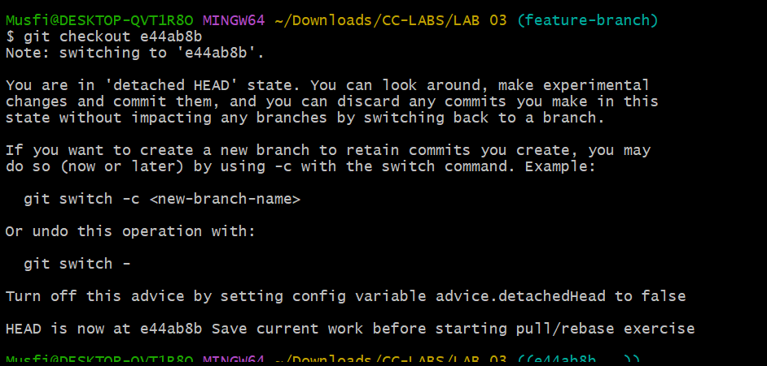
- Returned to main branch
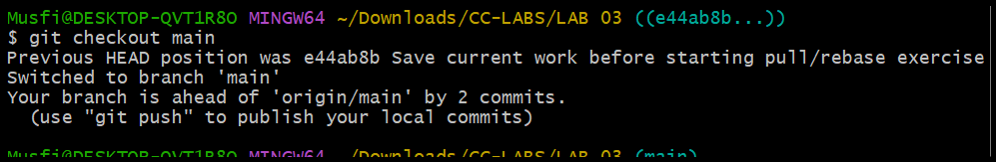
Task 6
Resetting Commits (Soft vs Hard Reset)
- First change committed
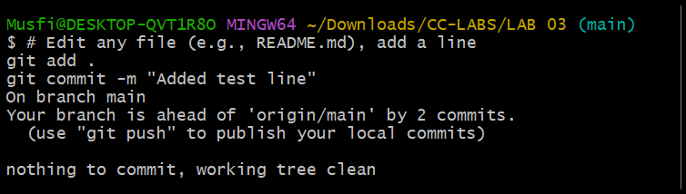
- Second change committed
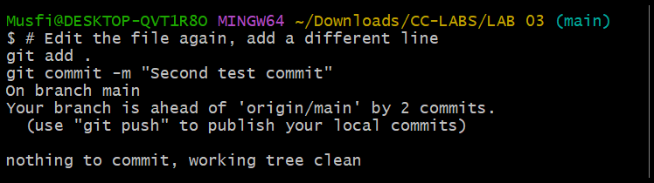
- Commit history viewed before reset
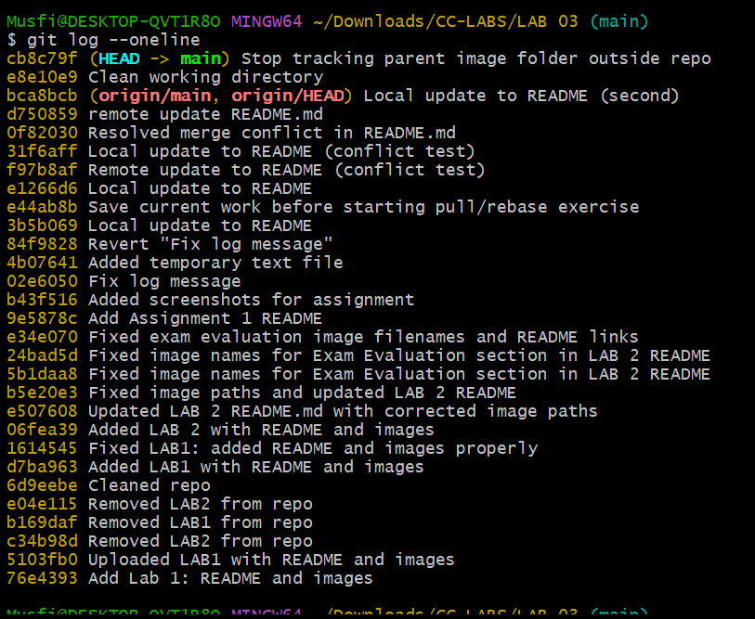
- File verified with both changes
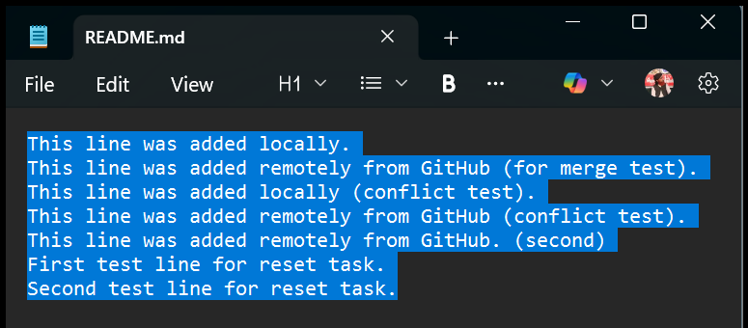
- Soft reset performed (changes kept staged)
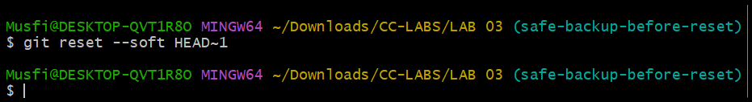
- Commit history after soft reset
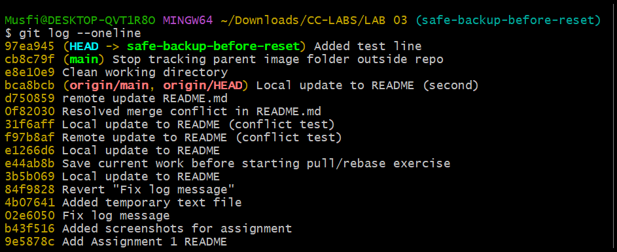
- File verified after soft reset
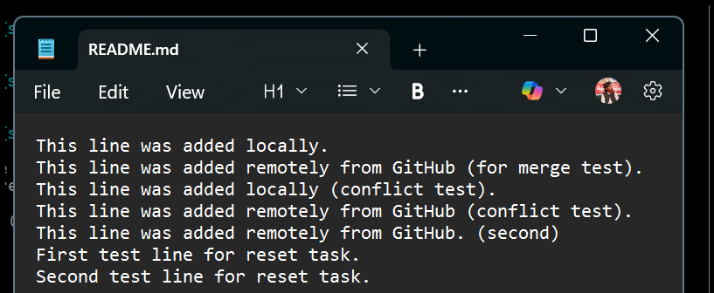
- Re-commit performed
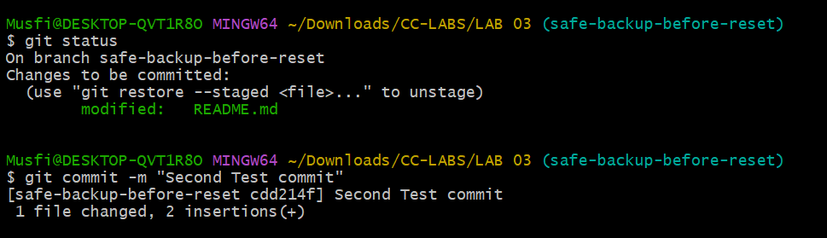
- Hard reset performed (changes discarded)
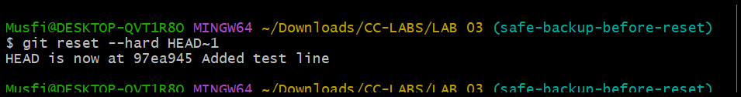
- Commit history after hard reset
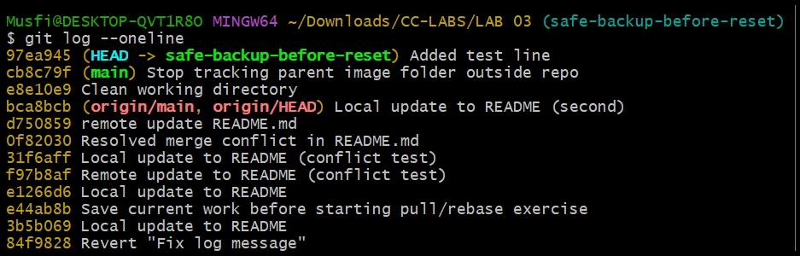
- File verified after hard reset
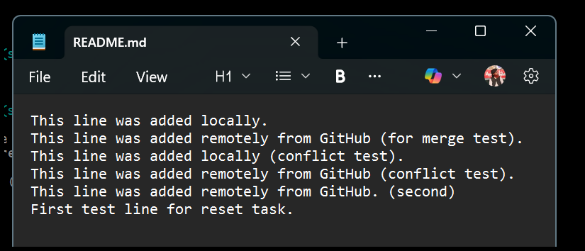
Task 7
Amending the Last Commit
- Initial change committed
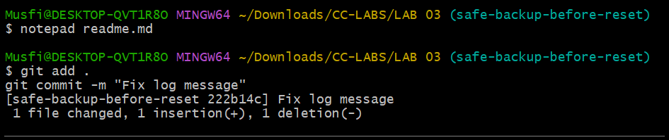
- Forgot changes added and last commit amended
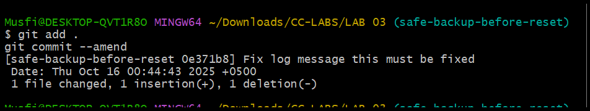
Task 8
Reverting a Commit (Safe Undo on Remote Branch)
- Temporary change committed and pushed
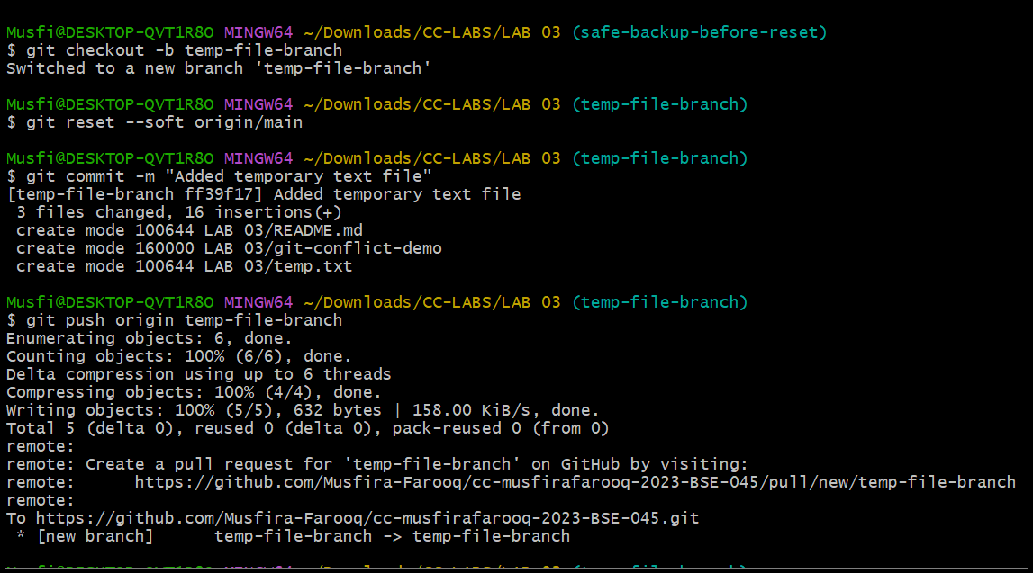
- Commit reverted safely
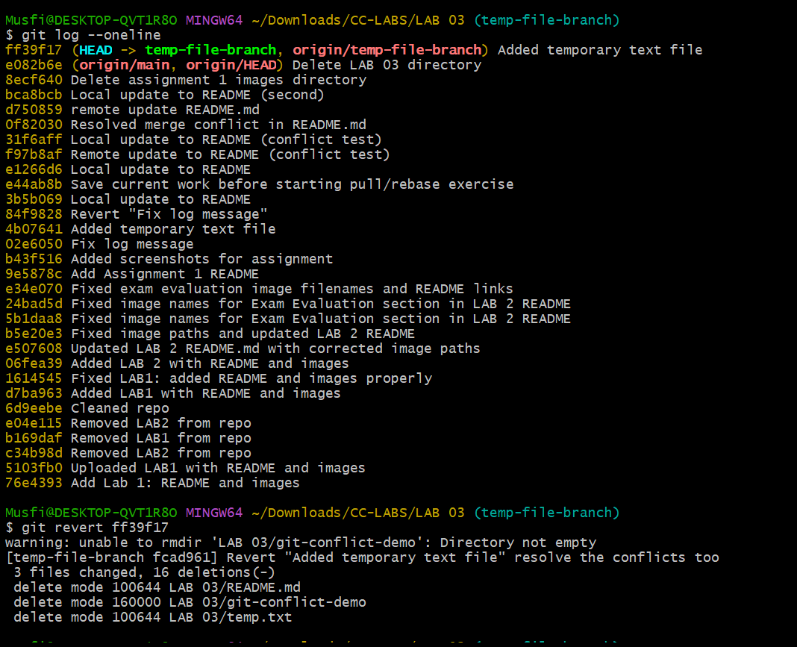
- Revert commit pushed to remote
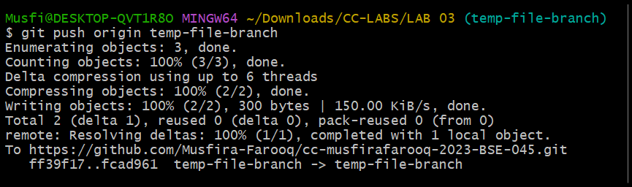
Task 9
Force Push (With Caution)
- New branch created for testing force push
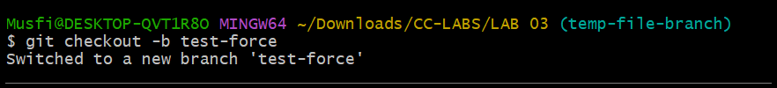
- Small change committed on the branch
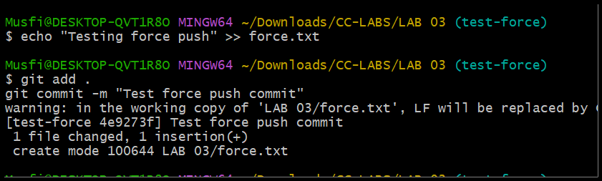
- Change pushed normally to remote
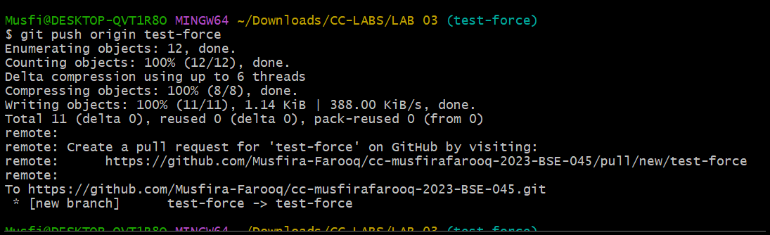
- Hard reset performed locally
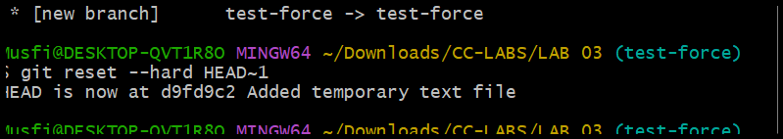
- Push rejected due to remote being ahead
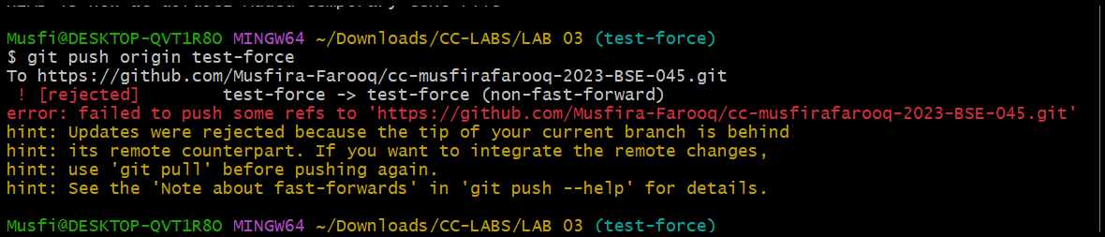
- Force push used to update remote branch
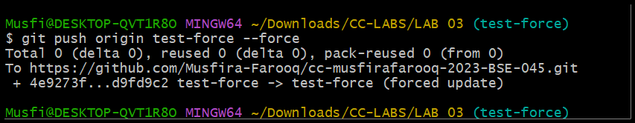
Task 10
Running Gitea in GitHub Codespaces via Docker Compose
- Gitea repository forked to own GitHub account
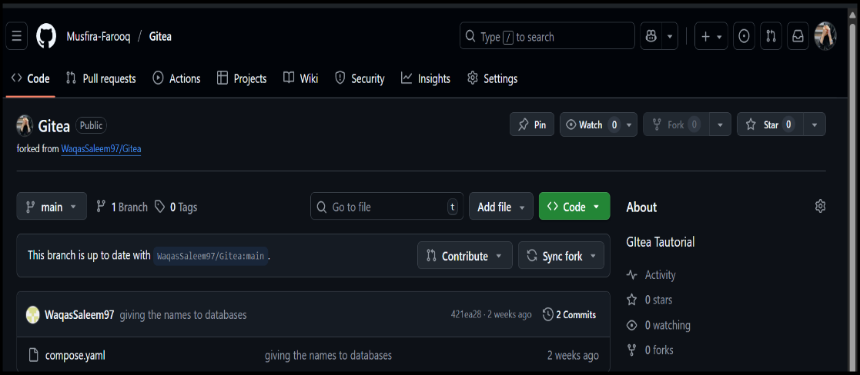
- Codespace created and loaded for the forked repo
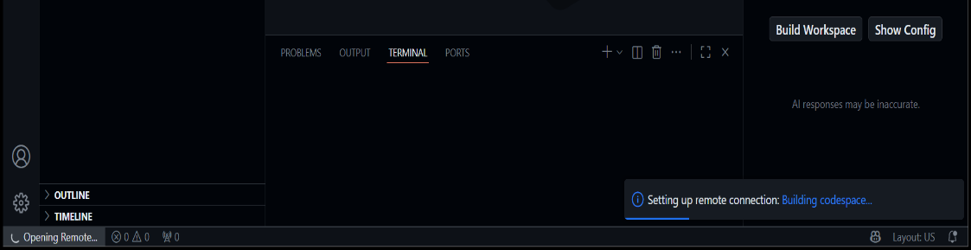
- Gitea started using Docker Compose in Codespaces
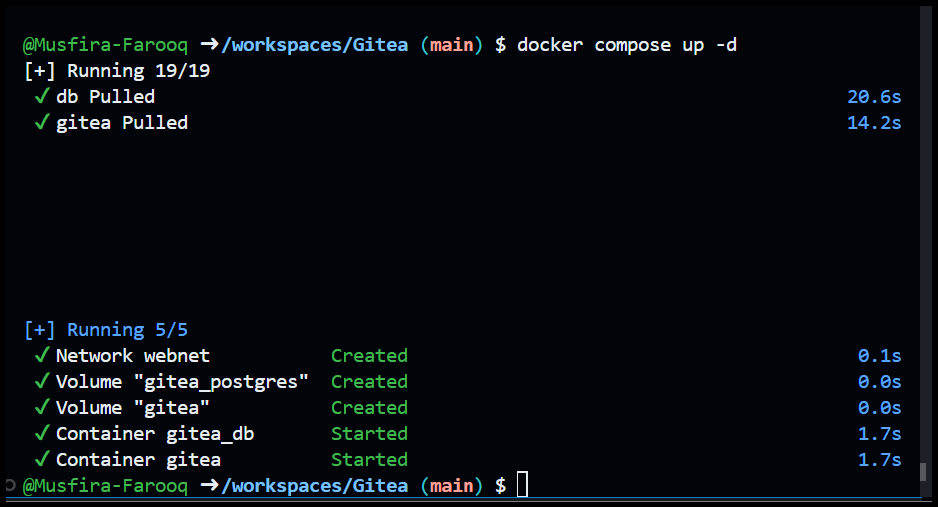
- Accessed Gitea web interface via port forwarding
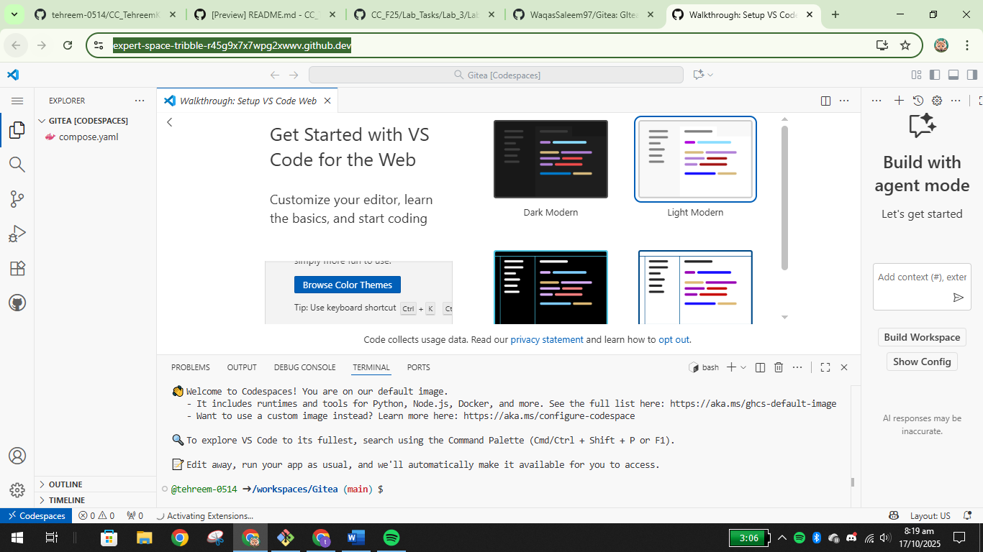
- Gitea installed with admin credentials
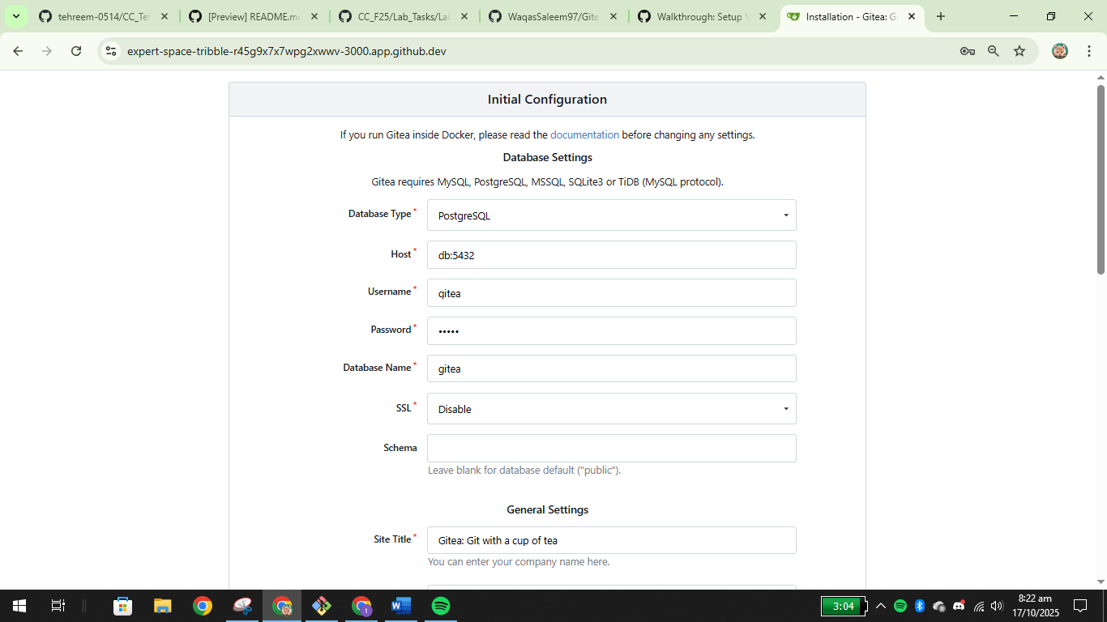
- Logged into Gitea dashboard
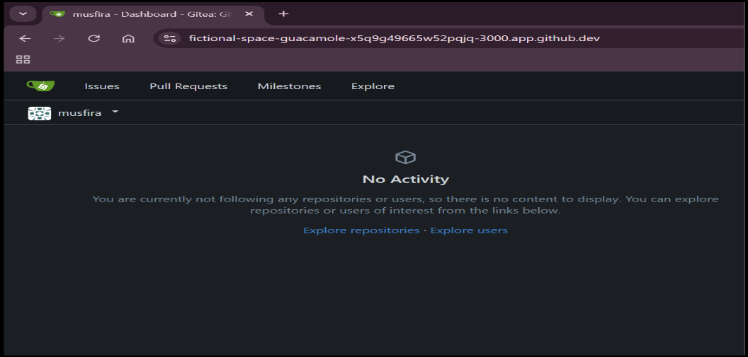
- New repository created inside Gitea
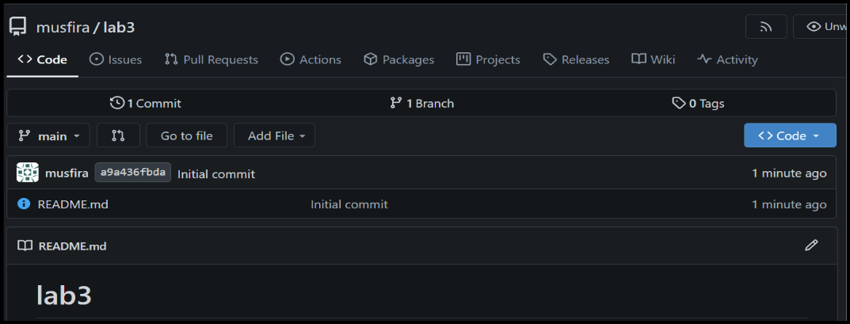
Task 11
Creating a GitHub Pages Portfolio Site
- GitHub Pages repository created with username.github.io
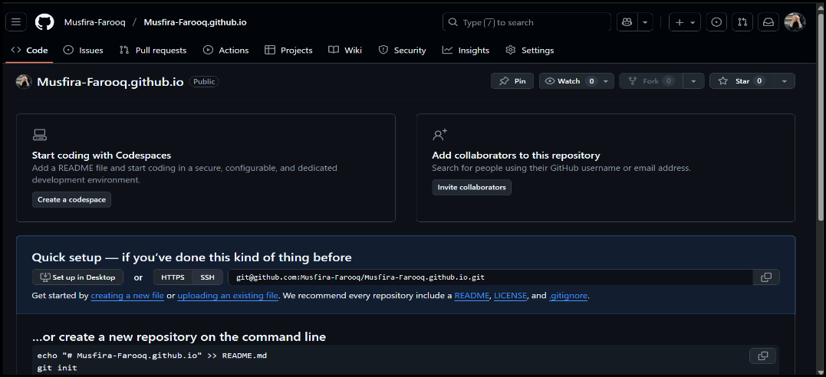
- Static website code prepared locally
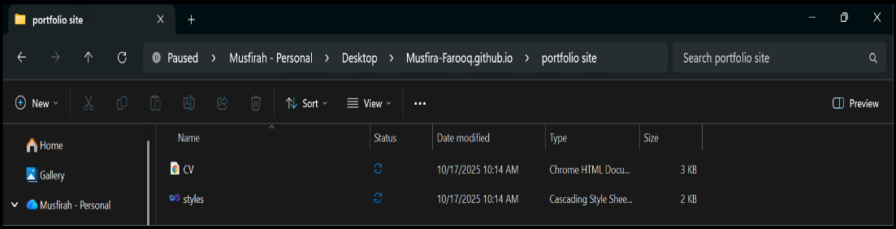
- Files added, committed, and pushed to GitHub
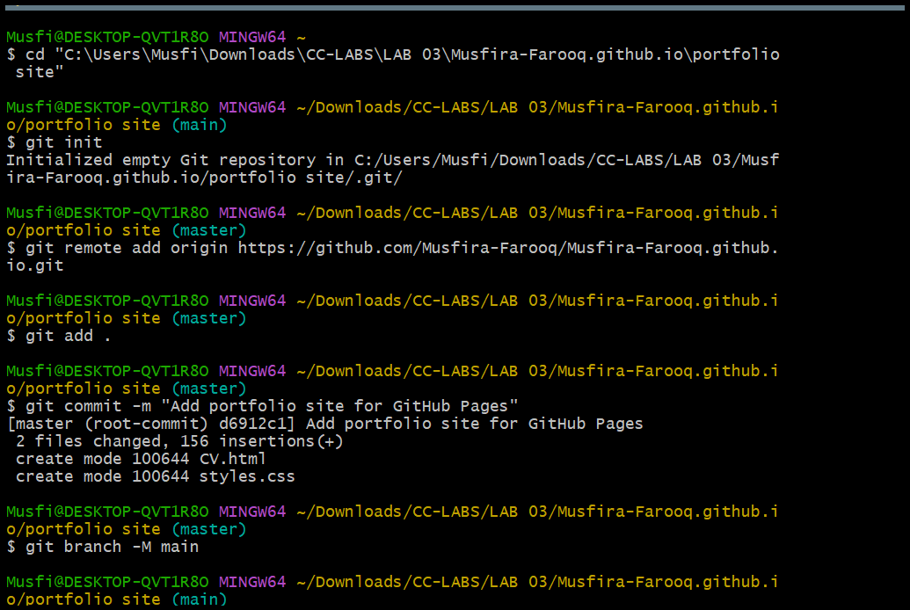
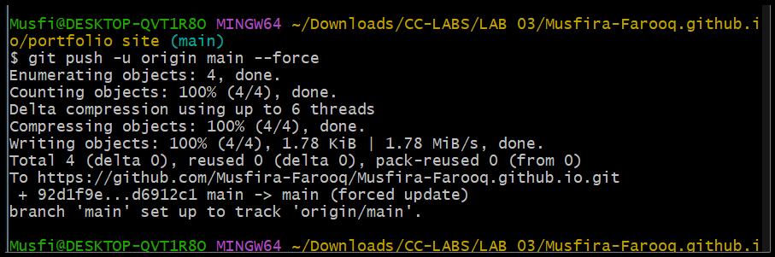
- GitHub Pages settings checked and site published
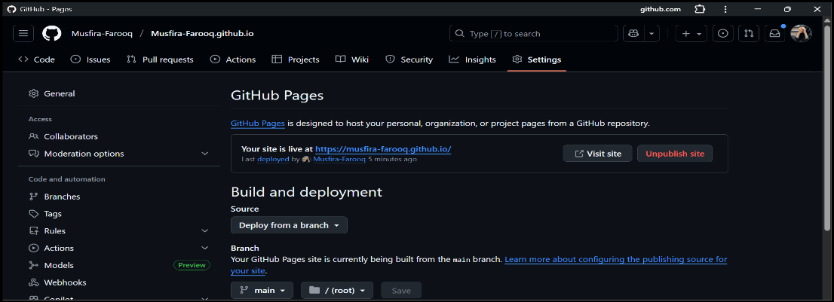
- Live site visited in browser and verified
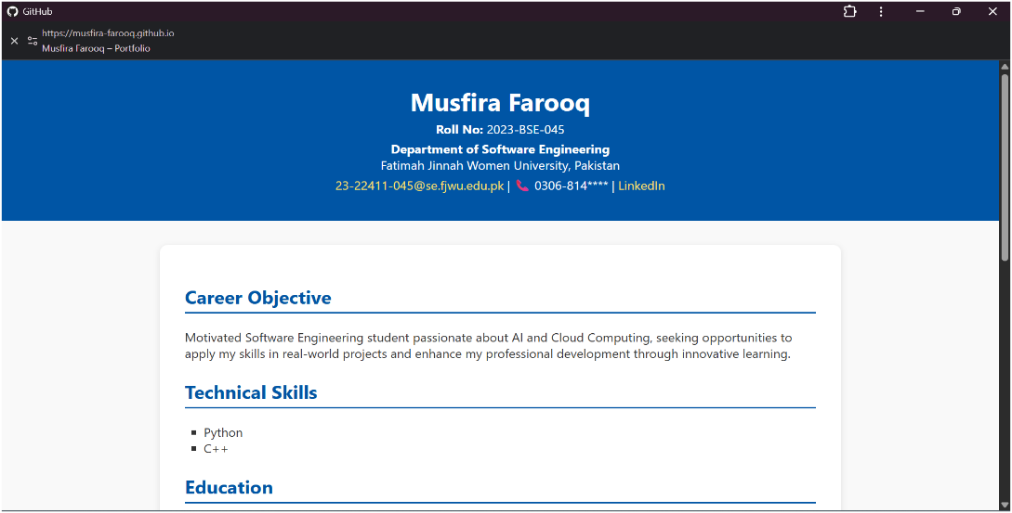
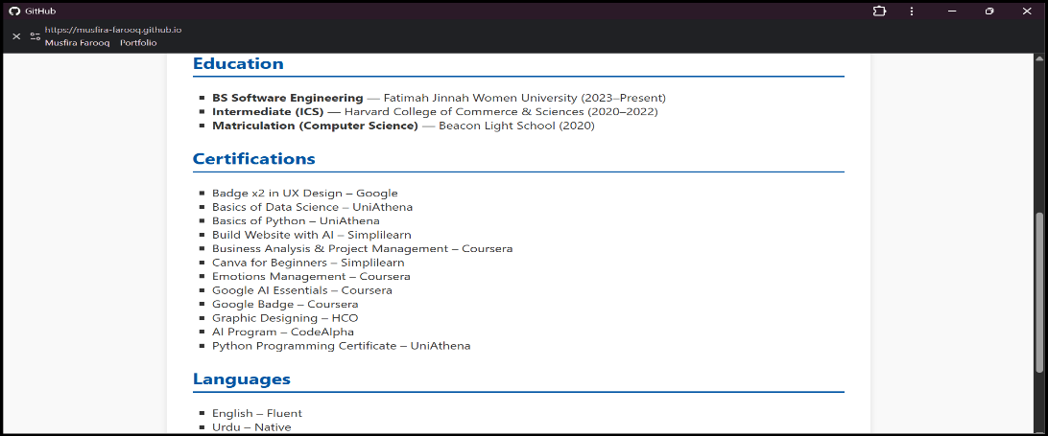
https://musfira-farooq.github.io/
Exam Evaluation Questions
Q1: Local vs Remote Conflict Resolution
- Remote edit committed
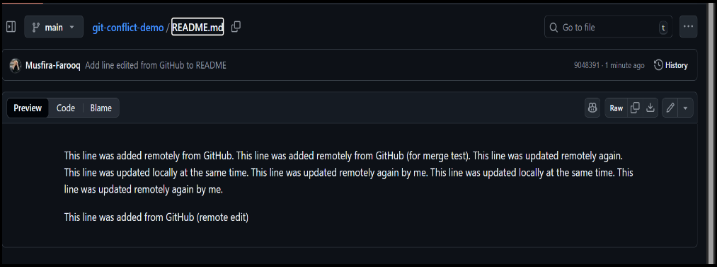
- Local edit committed
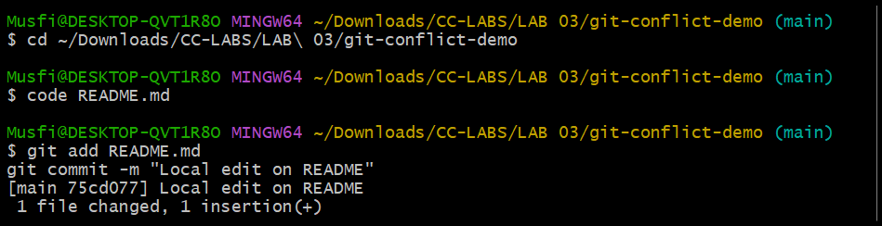
- Push error observed
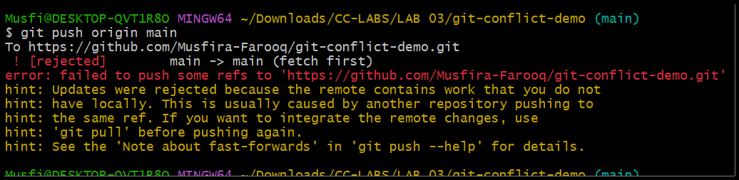
- Conflict resolved via merge and pushed
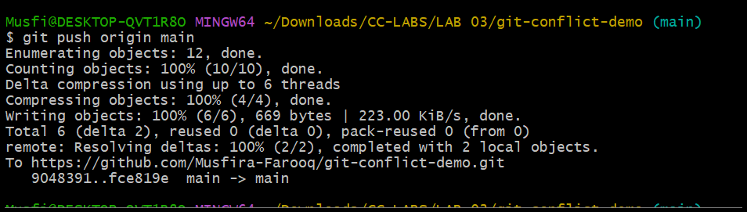
- Conflict resolved via rebase and pushed
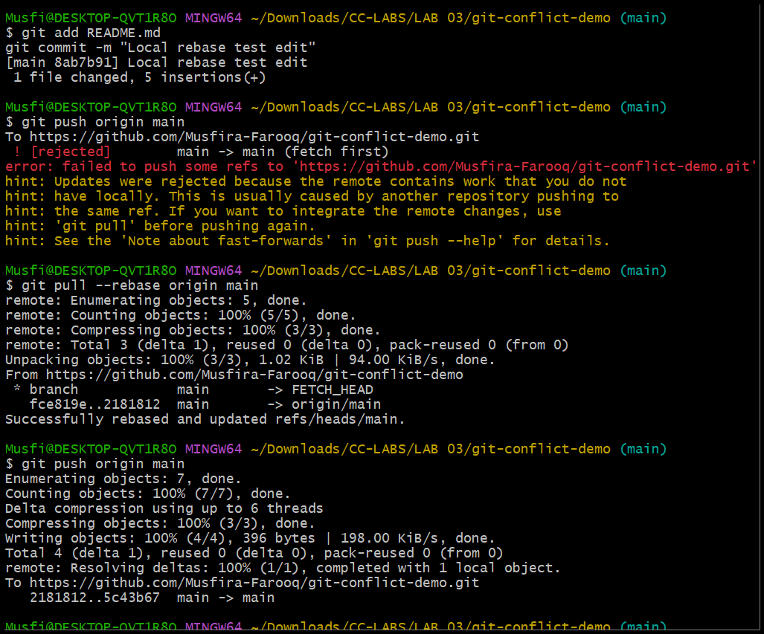
Q2: Manual Merge Conflict Handling
- Remote conflicting edit
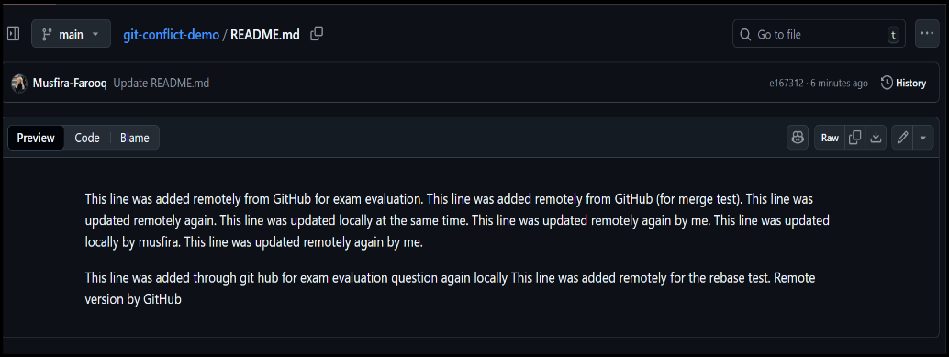
- Local conflicting edit
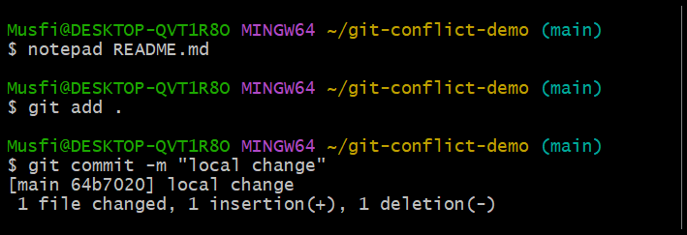
- Push rejected due to conflict
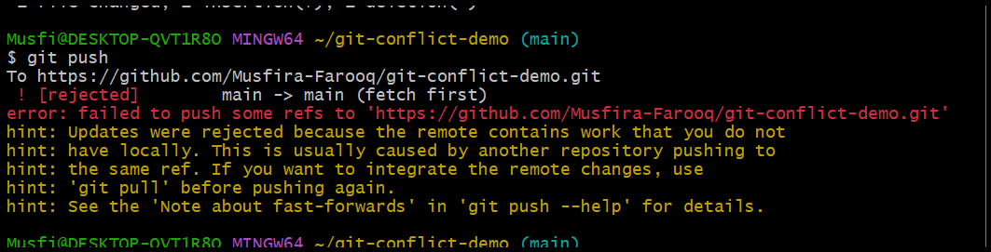
- Conflict triggered via rebase
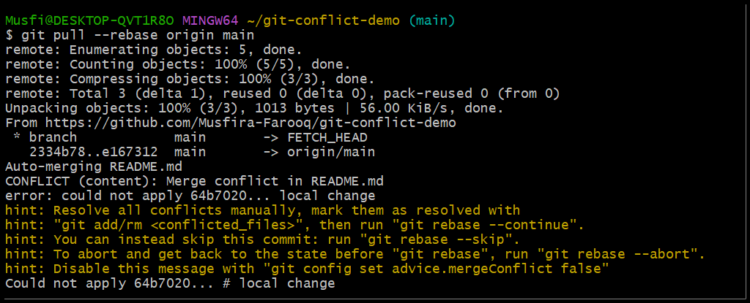
- File manually resolved
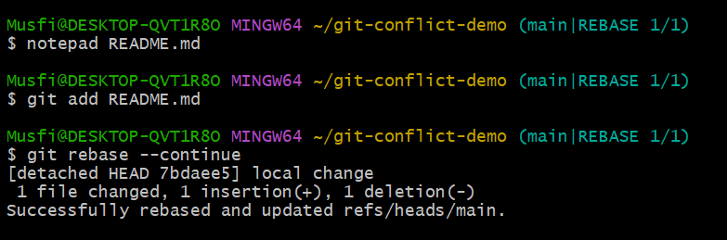
- Rebase continued and changes pushed
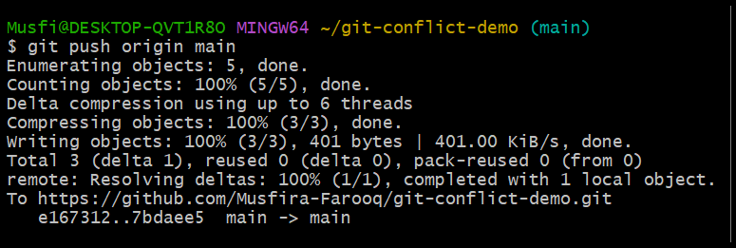
Q3: Managing Ignored and Tracked Files
- Folder created locally
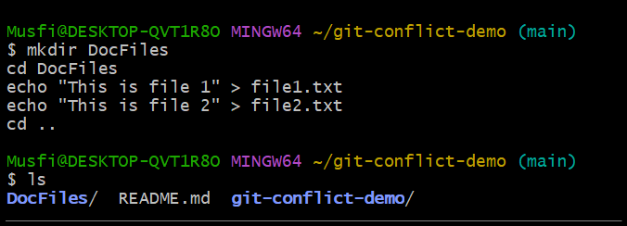
- Files committed and pushed
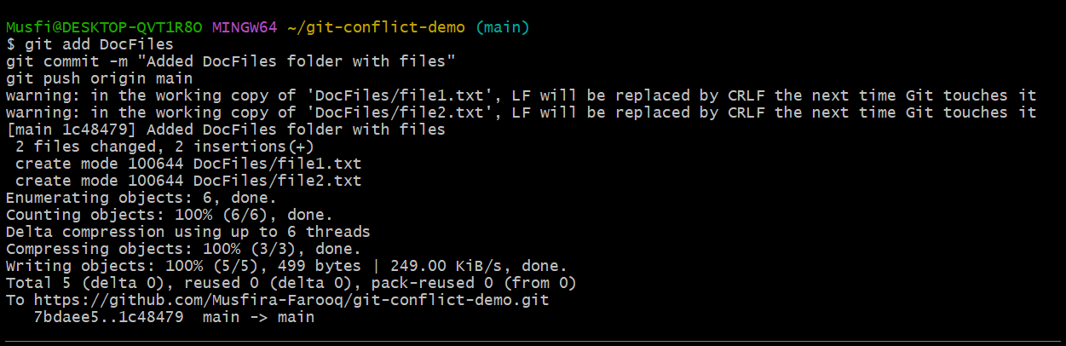
- Folder added to .gitignore
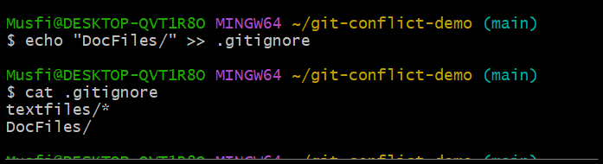
- .gitignore changes committed and pushed
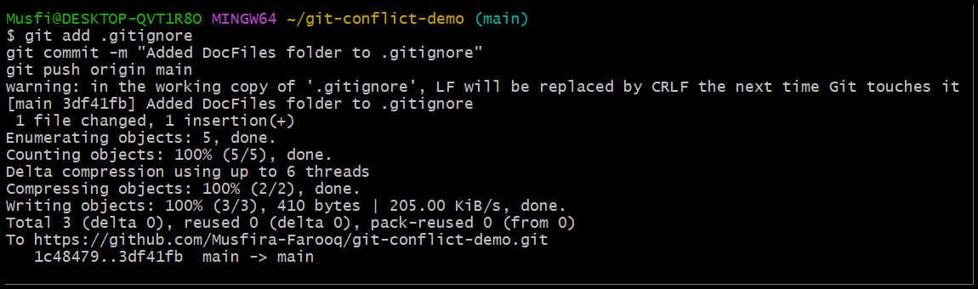
- Folder untracked from Git
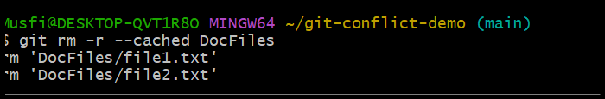
- Folder removed from GitHub
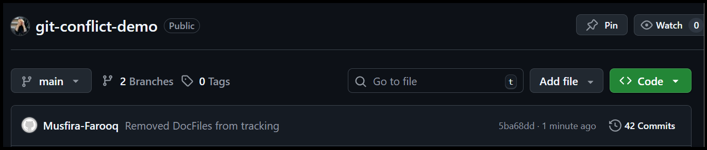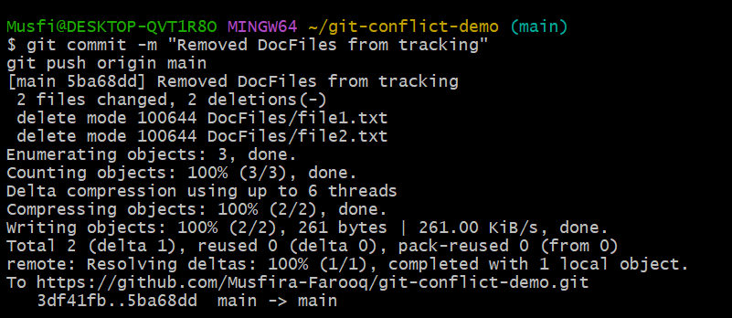
- Q4: Commit History Manipulation and Recovery
- First commit made
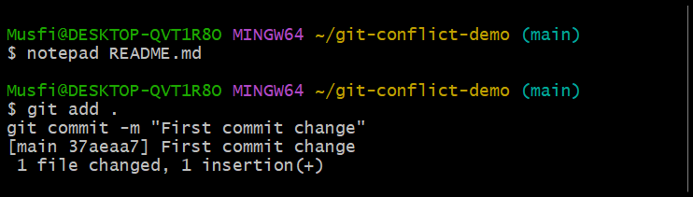
- Second commit made
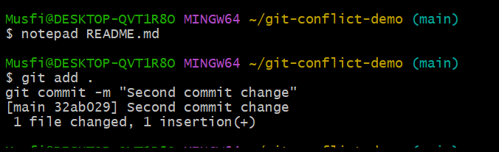
- Commit history viewed
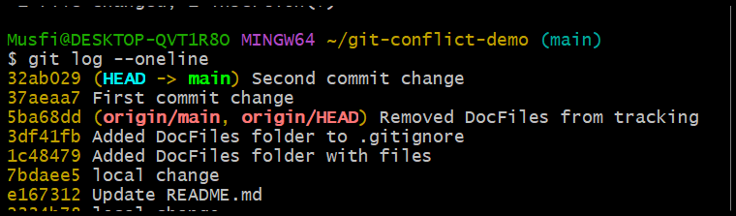
- Soft reset performed
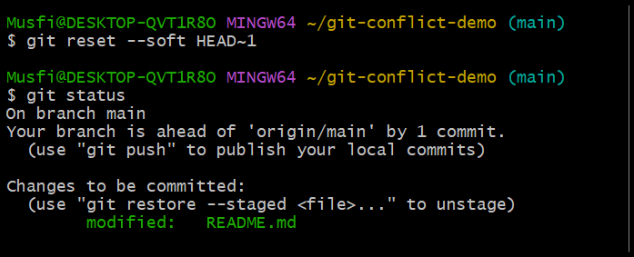
- Third commit made again
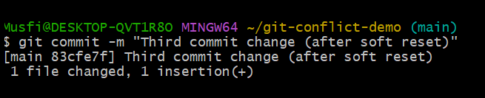
- Hard reset performed
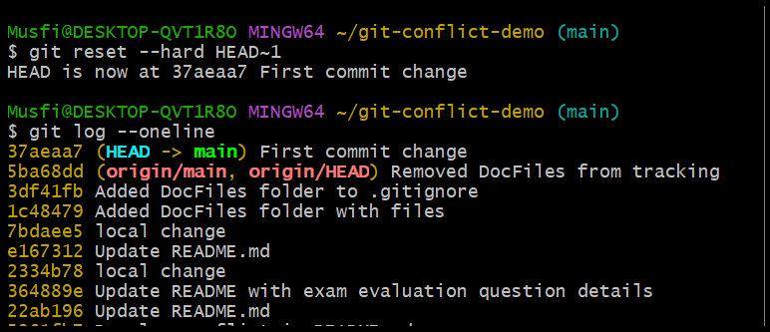
url of github repository: https://github.com/Musfira-Farooq/git-conflict-demo.git

